1 July 2019

Leadership Election and Events

Dear Member

It is our intention to hold a debate on the Future of the Conservative Party and the Leadership Election. It will be run on similar line to the BBC’s question time and Claire Perry MP will be in attendance. Claire has yet to declare her support for one of the candidates and would welcome your views. Details are contained in the attachment below. The venue has limited capacity so please respond promptly as entry will be limited to those on the list of applicants.

I also attach an extract from our website of our upcoming events which also includes this debate. We look forward to meeting you at some of them.

Yours sincerely



Leadership Election

As you are probably aware the leadership election process is being run entirely from Central Office. Hustings are taking place at the following locations and you should have received notification of them along with instructions to apply to attend. If you have not then please email leadership@conservatives.com

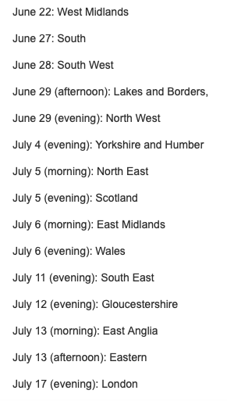

The closest location is Gloucestershire on July 12th and as yet the location and timings are not known by the DCCA but CCHQ will furnish you with details 48 hours prior to the event if you apply to the email address above.

Please note if you have joined the party after April 22nd 2019, you will be ineligible to vote for the future leader of the party.

Future Events

DCCA Debate – Future of the Conservative Party and the Leadership Election

We plan to have our own debate on Thursday 11th July at the Devizes Conservative Club, commencing at 1930, Claire Perry will be in attendance. She has yet to decide on which candidate to support and would welcome your views.

We are limited to 60 in the function room and therefore ask that you book a place by emailing or calling the office to be place on the list of attendees which will allow entry into the meeting.

Devizes & Rural District Branch Cream Tea
7th July 2019 3 p.m. - 5 p.m. - Eastwell Manor, SN10 5QG.
Eastwell was built in 1570 by the Grubbe family and the estate features walls and terraces from the 16th and 17th centuries, including an elegant banqueting house.
Burbage Branch Summer Drinks Party
Gaisford Farm, High Street, Burbage, SN8 3AB.
7th July 2019 noon - 2 p.m.

Admission £8 (wine and nibbles included.)
To book your place/for further details please contact Mr Sonny Hamid sonnyhamid8@gmail.com

Association Clay Pigeon Shooting Challenge and Barbecue
13th July 2019 - The Barbury Shooting School, near Barbury Castle, Wroughton, Swindon, SN4 0QH.
For full details please contact Peter Sharpe peter.sharpe5@me.com
CWCC Ladies Lunch
30th September 2019 12.15 p.m.
North Wilts Golf Club, Blacklands, SN10 2LP.
Guest Speaker: Wiltshire Councillor Mrs Laura Mayes
Two-course meal.
Licensed Bar.
Enquiries: Mrs Janet Giles janetmgiles10@gmail.com
CWCC Ladies Lunch
22nd November 2019 12.15 p.m.
North Wilts Golf Club, Blacklands, SN10 2LP.
Guest Speaker The Right Honourable Claire Perry MP
Two-course meal.
Licensed Bar.
Enquiries: Mrs Janet Giles janetmgiles10@gmail.com

